**Assignment No.15**

**Problem Statement:**

Create a serverless computing service.

**Solution:**

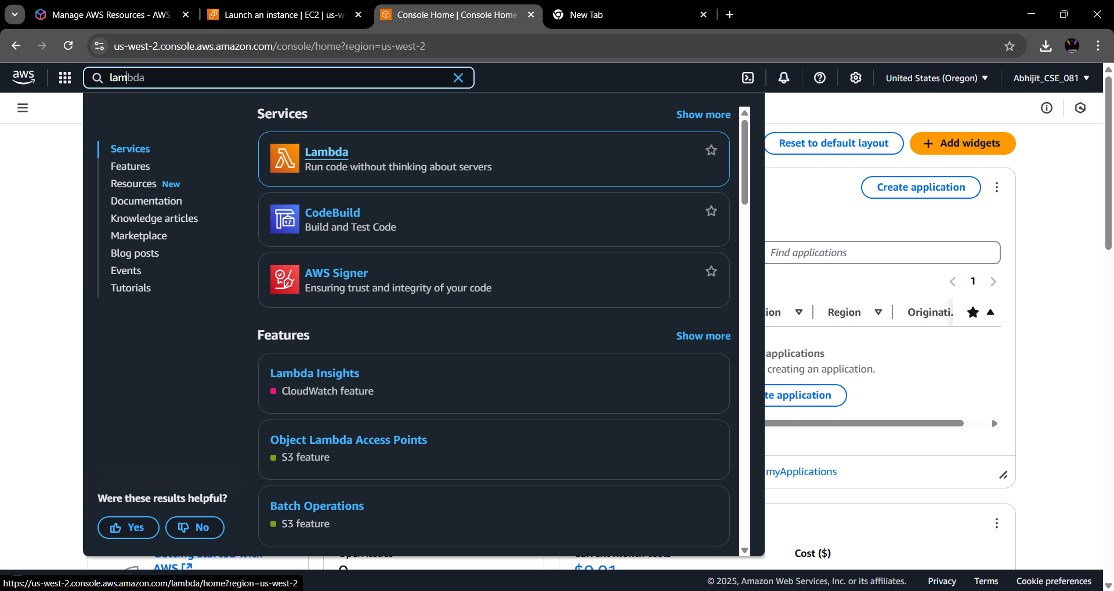**Step 1:** Search for Lambda and click on it.

**Step 2:** Click on Create a function button.

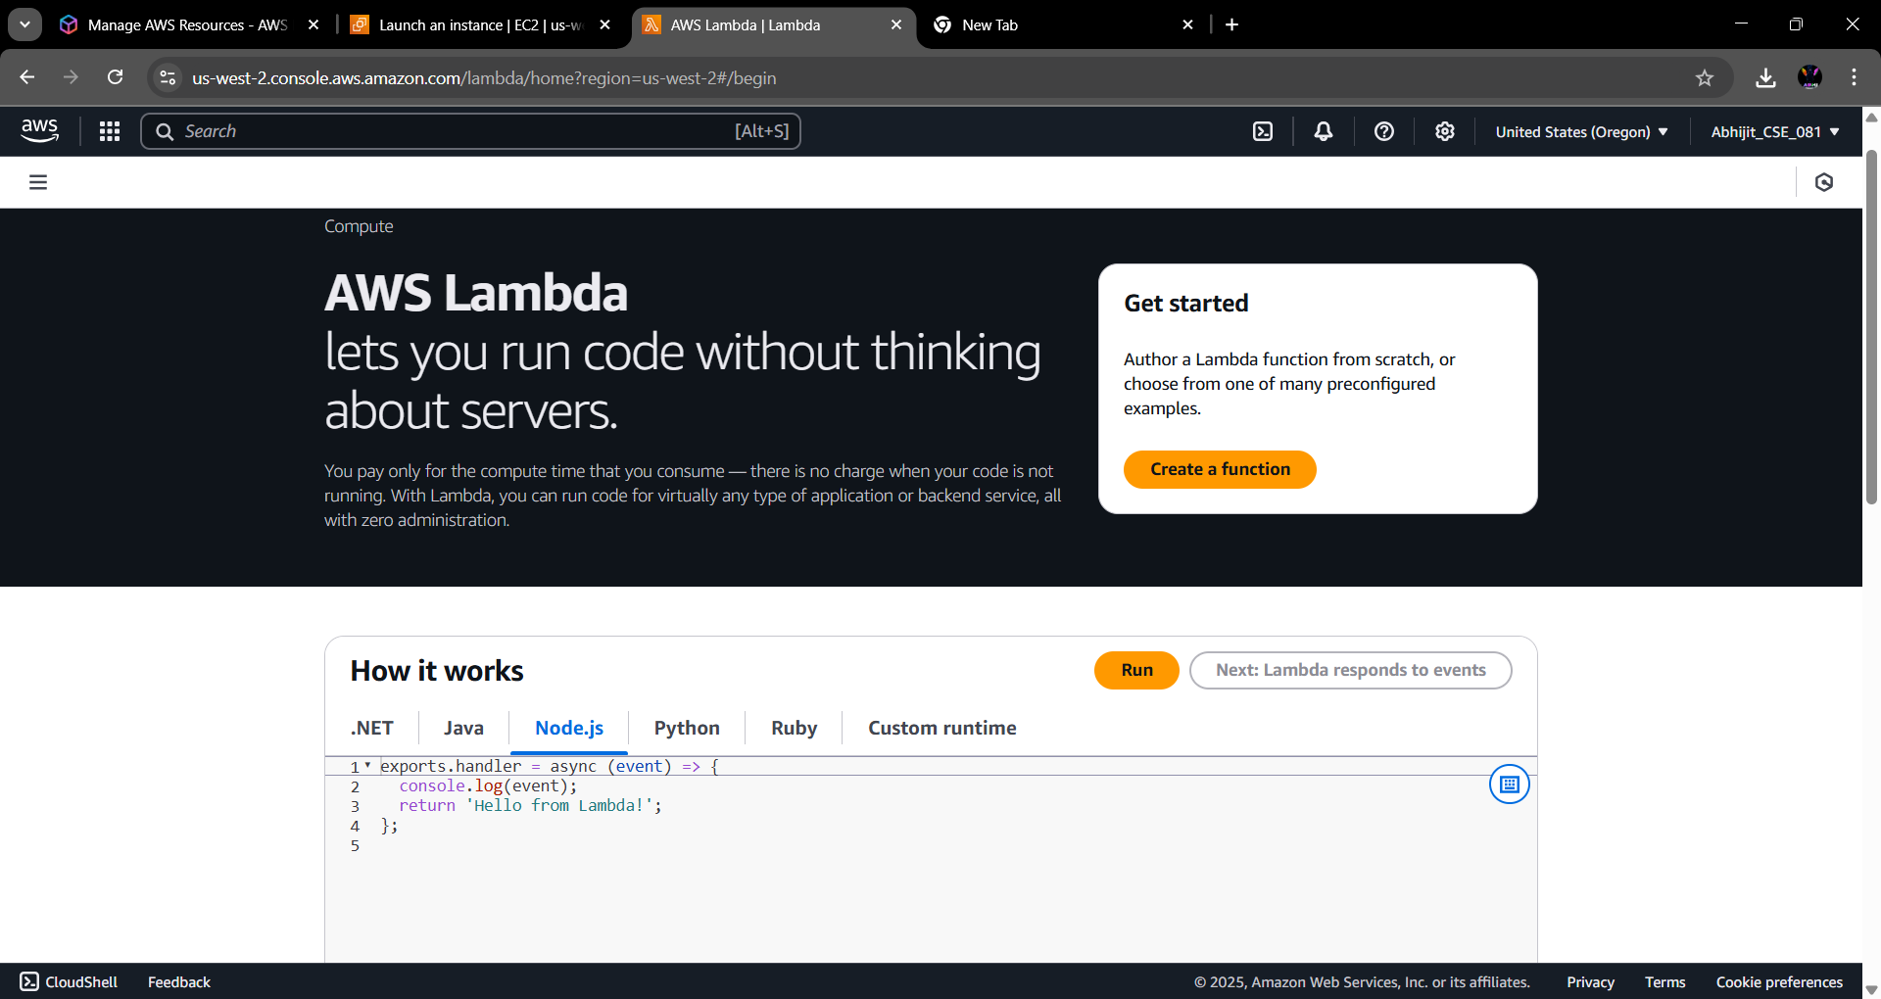

**Step 3:** Give a name to the function and under runtime select Node.js.22. x.

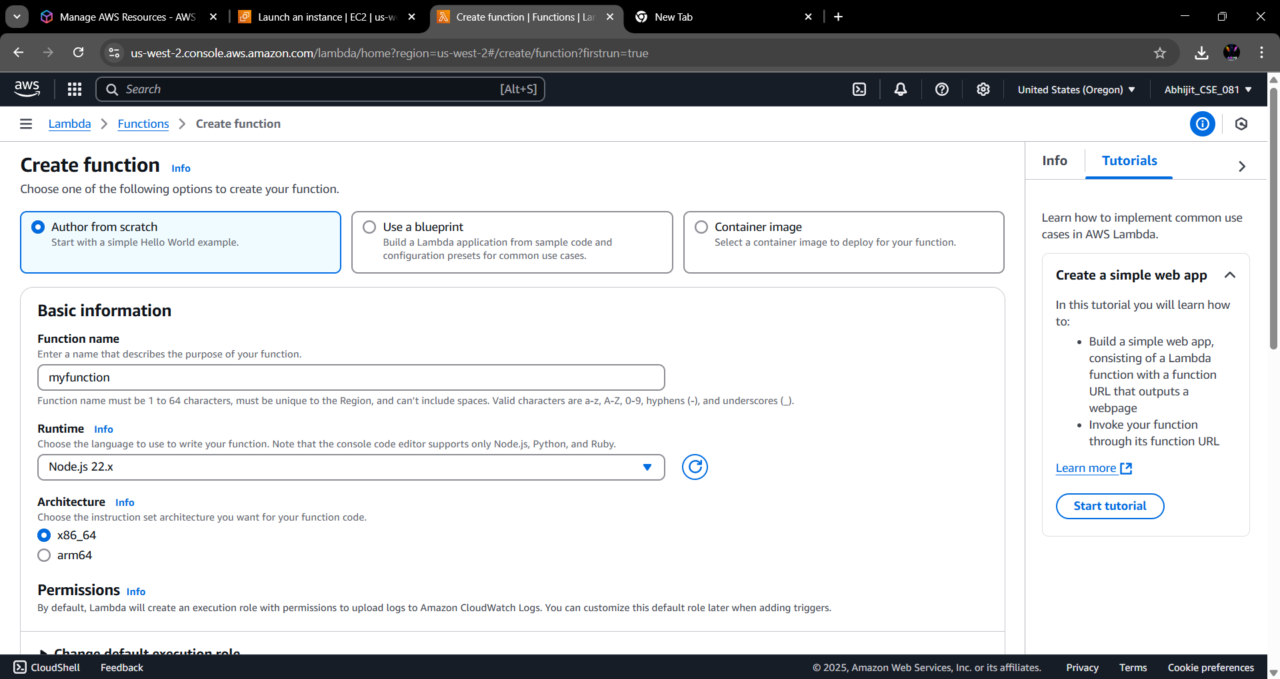

**Step 4:** Under the Advanced settings, check the Enable Function URL checkbox & under Auth type, select NONE. Then click on Create Function.

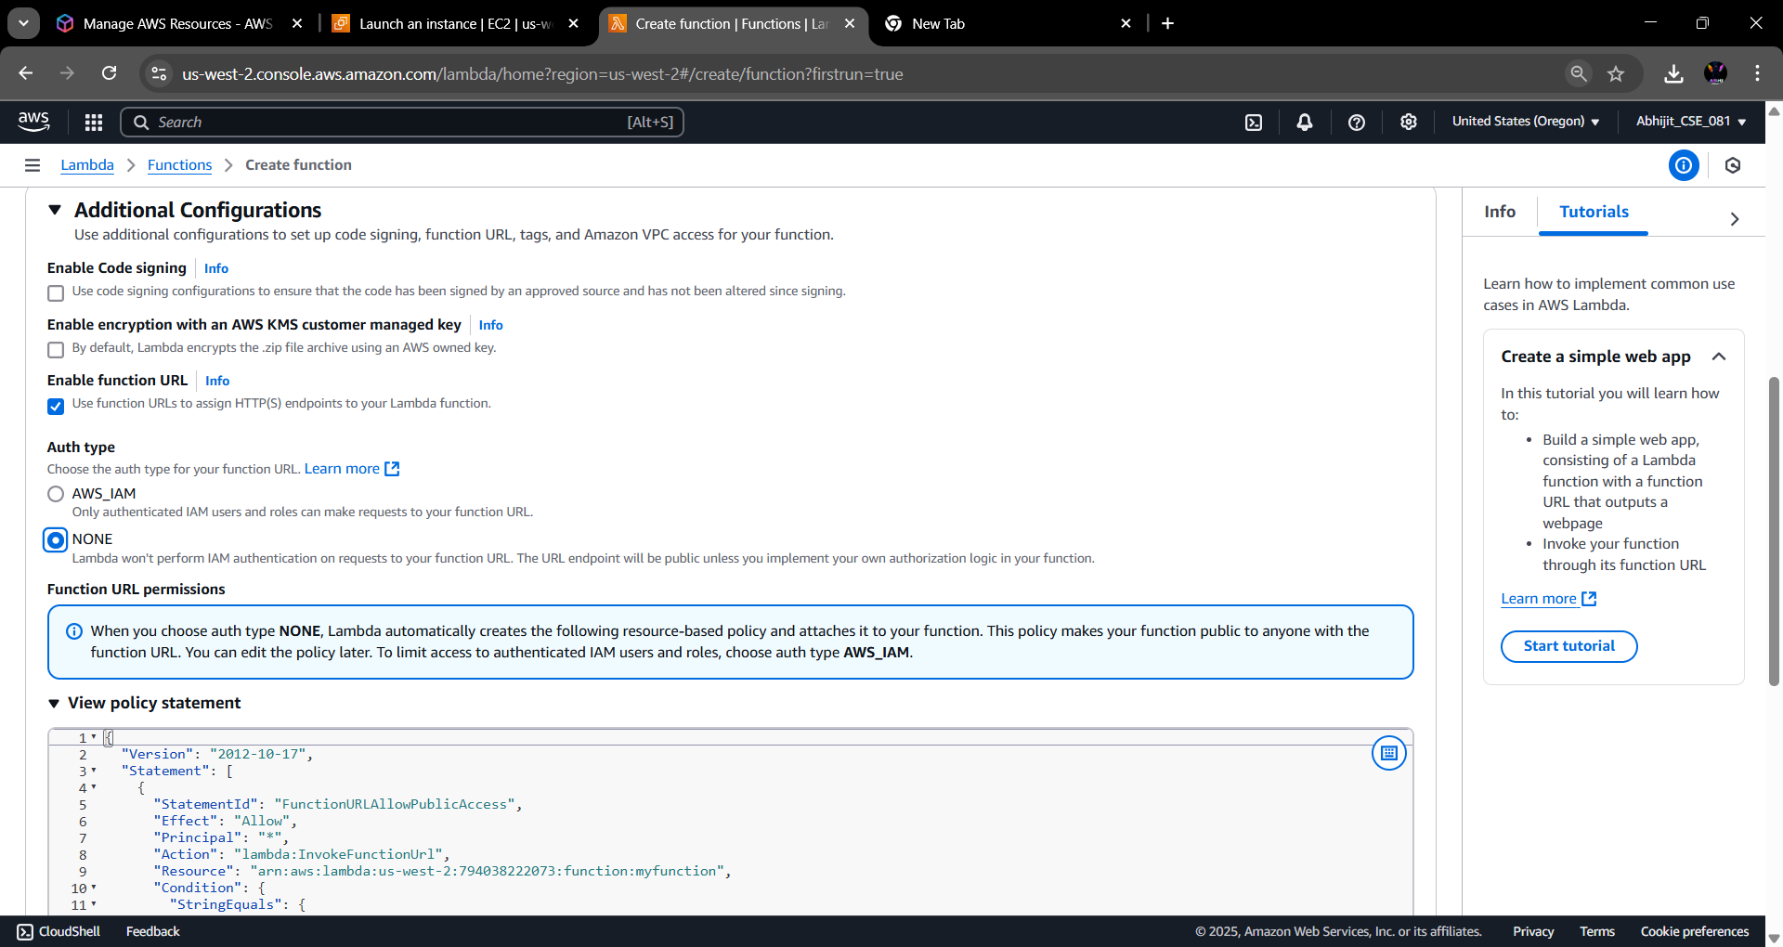

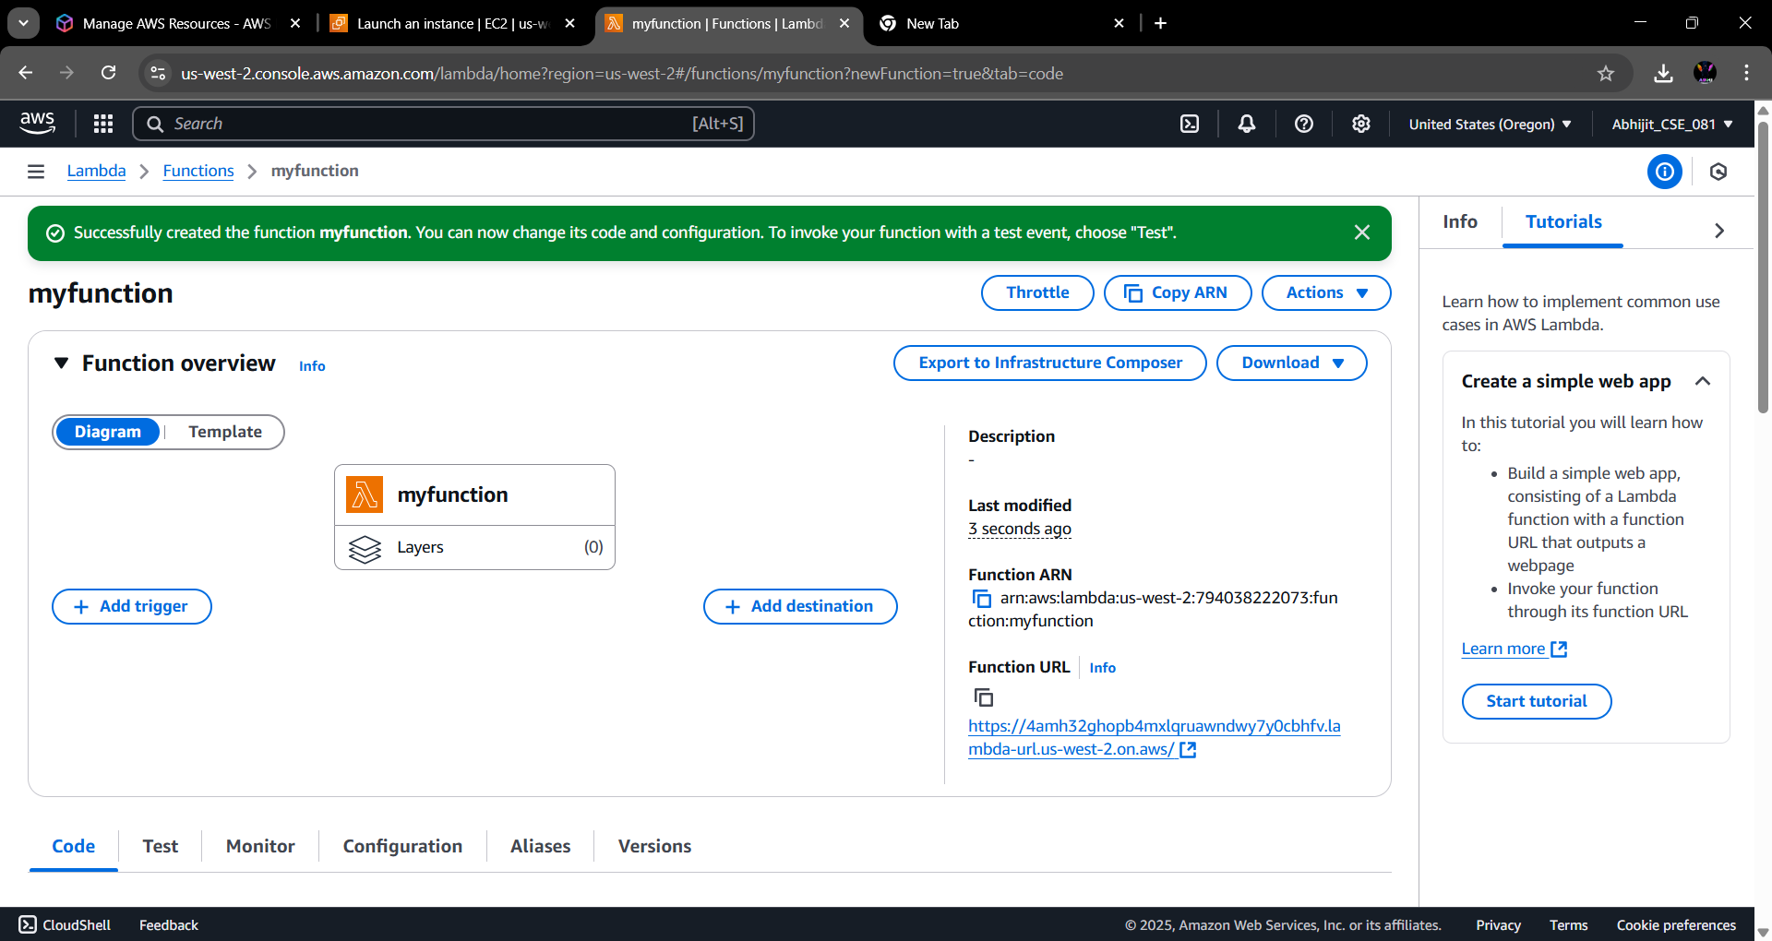**Step 5:** The function has been created. Now copy the function URL and paste it on a new tab.

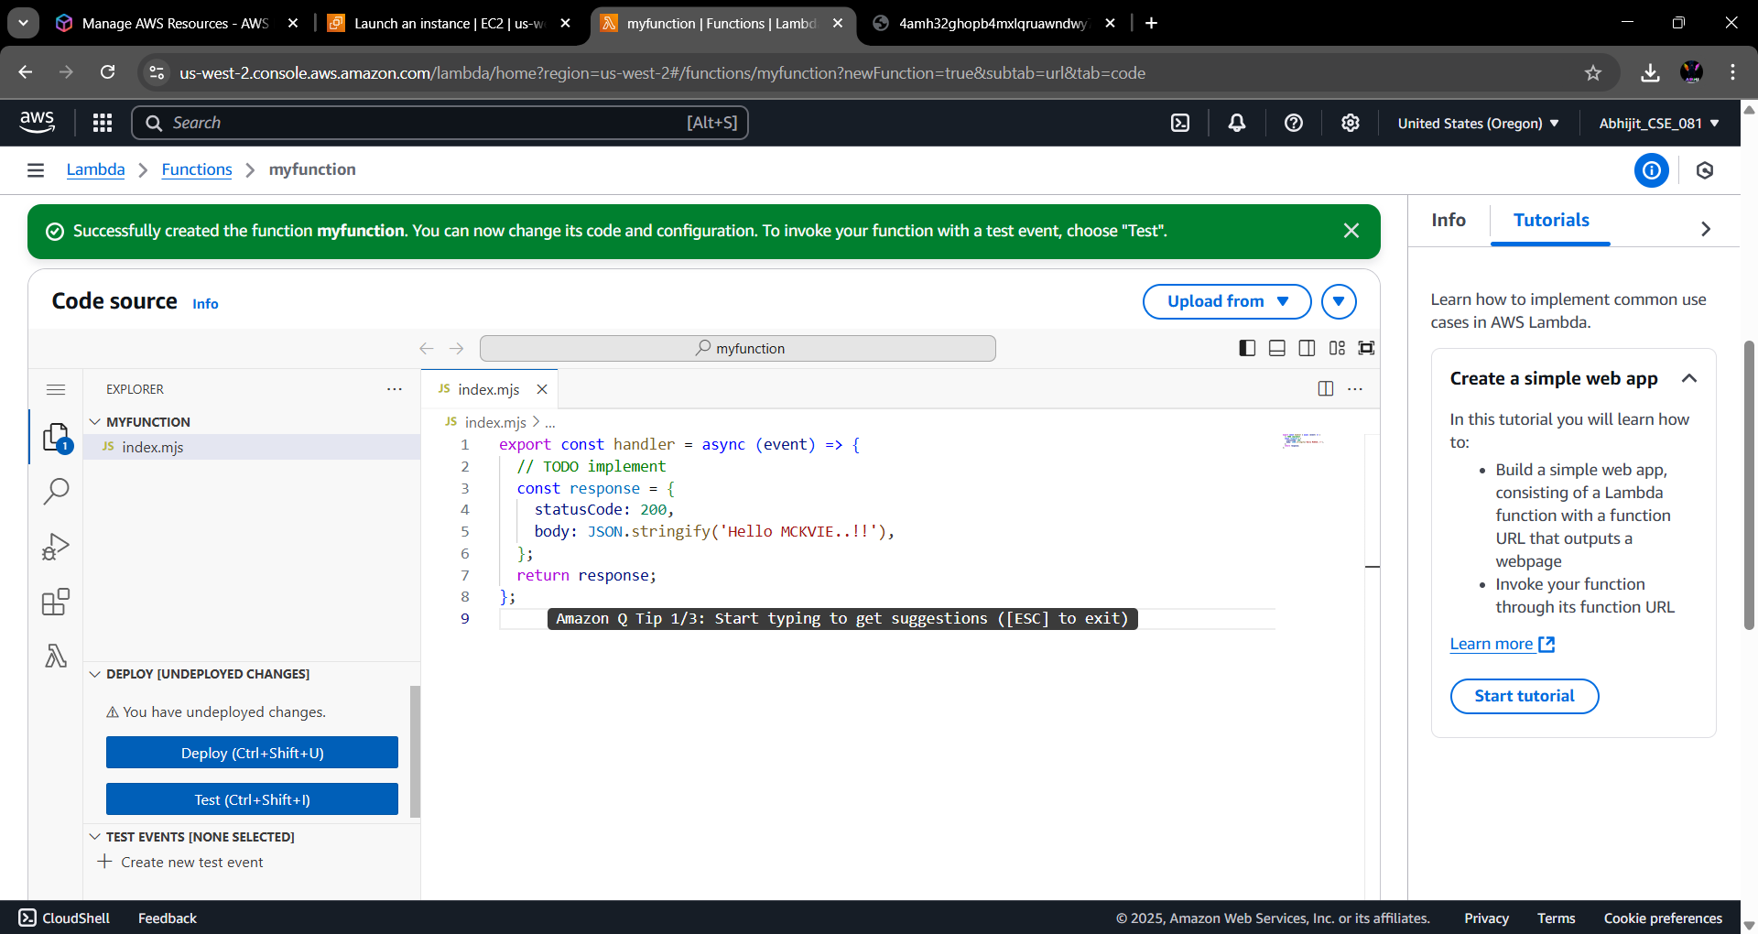**Step 3:** Click on the created function and go to the code section of it. There we modify some code and deployed it. open the function URL in a tab.

